Prasanna azure devops interview

1.Wt is the traffic manager,what is use case?

2.Wt is azure vm scale set?

3.Wt is use case of azure managed disk?how expand the disk in azure vm level?

4.U want secure remote access to azure without exposing rdp or ssh port on the public internet ,how to achieve it?

5.U have web application in azure vm and u want to ensure scalling,how can I achieve this?wt type load balancer using web application scalling vms?

6.Wt is best way setup hyper v in azure vm?can u explain what r check points?

7.How to add 1000 user in azure active directory?

8.Can u explain nsg vs asg in azure?

9.Did u wrk on a power shell with azure?

1.Wt is the traffic manager,what is use case?

<https://learn.microsoft.com/en-us/azure/traffic-manager/traffic-manager-overview>

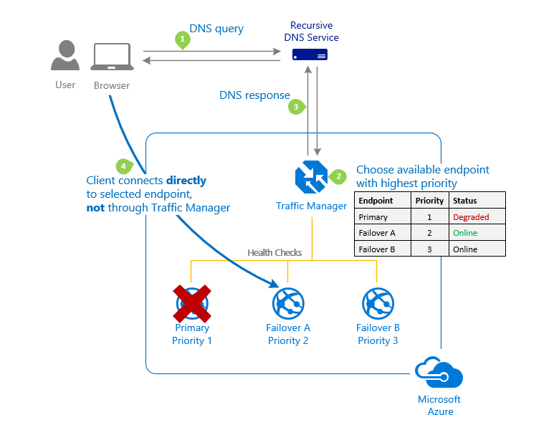

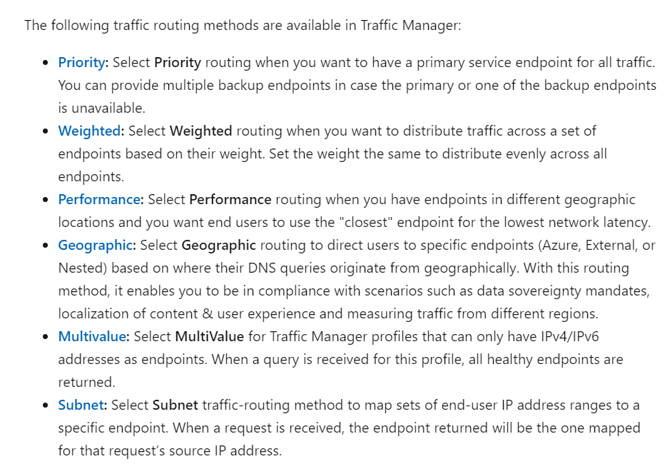

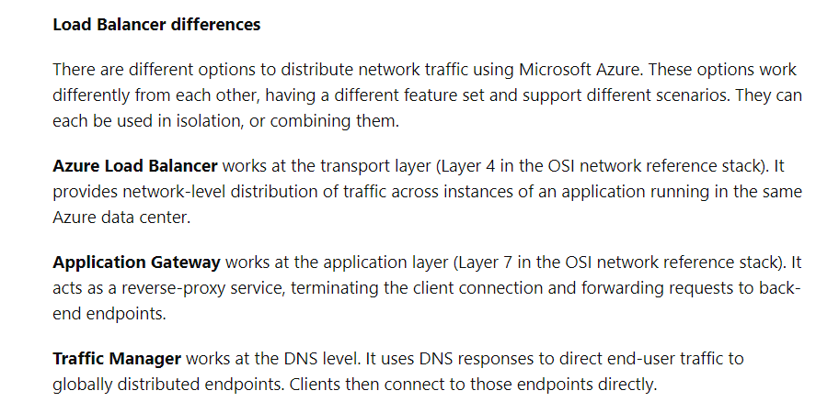

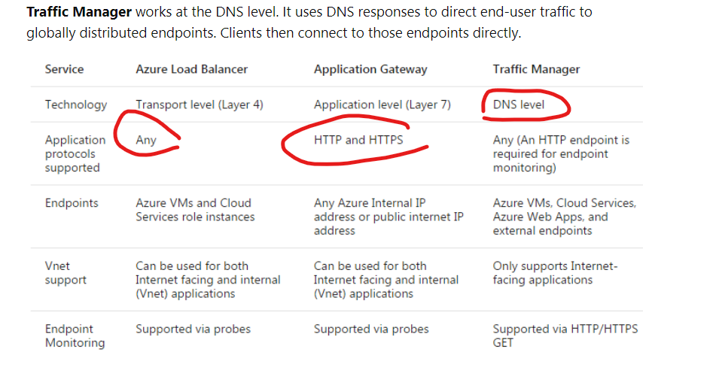

2.Wt is azure vm scale set?

Azure Virtual Machine Scale Sets let you create and manage a group of load balanced VMs. The number of VM instances can automatically increase or decrease in response to demand or a defined schedule. Scale sets provide the following key benefits: Easy to create and manage multiple VMs.

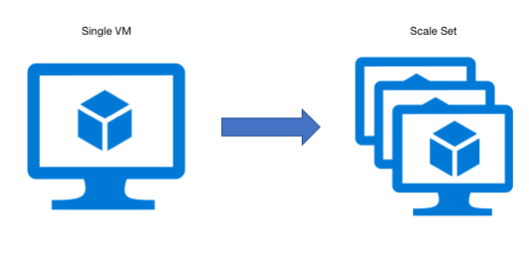

3.Wt is use case of azure managed disk?how expand the disk in azure vm level?

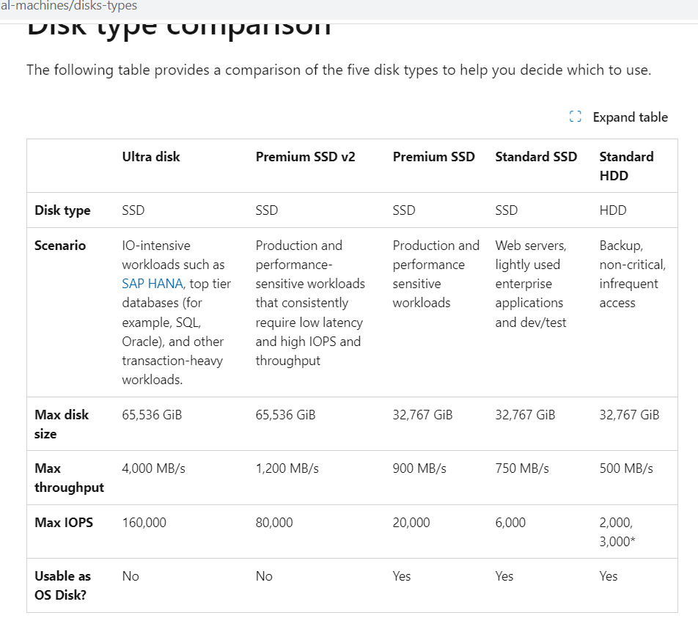

4. U want secure remote access to azure without exposing rdp or ssh port on the public internet ,how to achieve it?

<https://www.cloudninja.nu/post/2023/01/azurebastion/>

What should you use to secure connectivity and prevent exposing RDP SSH ports to the outside world for all virtual machines in a virtual network?

Azure Bastion provides secure connectivity to all of the VMs in the virtual network in which it's provisioned. Using Azure Bastion protects your virtual machines from exposing RDP/SSH ports to the outside world, while still providing secure access using RDP/SSH.

5.U have web application in azure vm and u want to ensure scalling,how can I achieve this?wt type load balancer using web application scalling vms?

<https://learn.microsoft.com/en-us/samples/azure/azure-quickstart-templates/vmss-windows-app-gateway/>

<https://stackoverflow.com/questions/70750103/using-vm-scale-sets-as-application-gateway-backend>

6.Wt is best way setup hyper v in azure vm? can u explain what r check points?

Checkpoints are useful for creating backups of virtual machines or testing software in an isolated environment without affecting the production environment. Hyper-V checkpoints capture the virtual machine's state at a particular moment, allowing you to revert the virtual machine to that state later if needed.

can u explain what r check points before creating hyper v in azure

Checkpoints are useful for creating backups of virtual machines or testing software in an isolated environment without affecting the production environment. Hyper-V checkpoints capture the virtual machine's state at a particular moment, allowing you to revert the virtual machine to that state later if needed

How to add 1000 user in azure active directory?

<https://learn.microsoft.com/en-us/entra/identity/users/users-bulk-add>

Can u explain nsg vs asg in azure?

The main difference between an NSG and an ASG is that an NSG is associated with a subnet, while an ASG is associated with a group of virtual machines

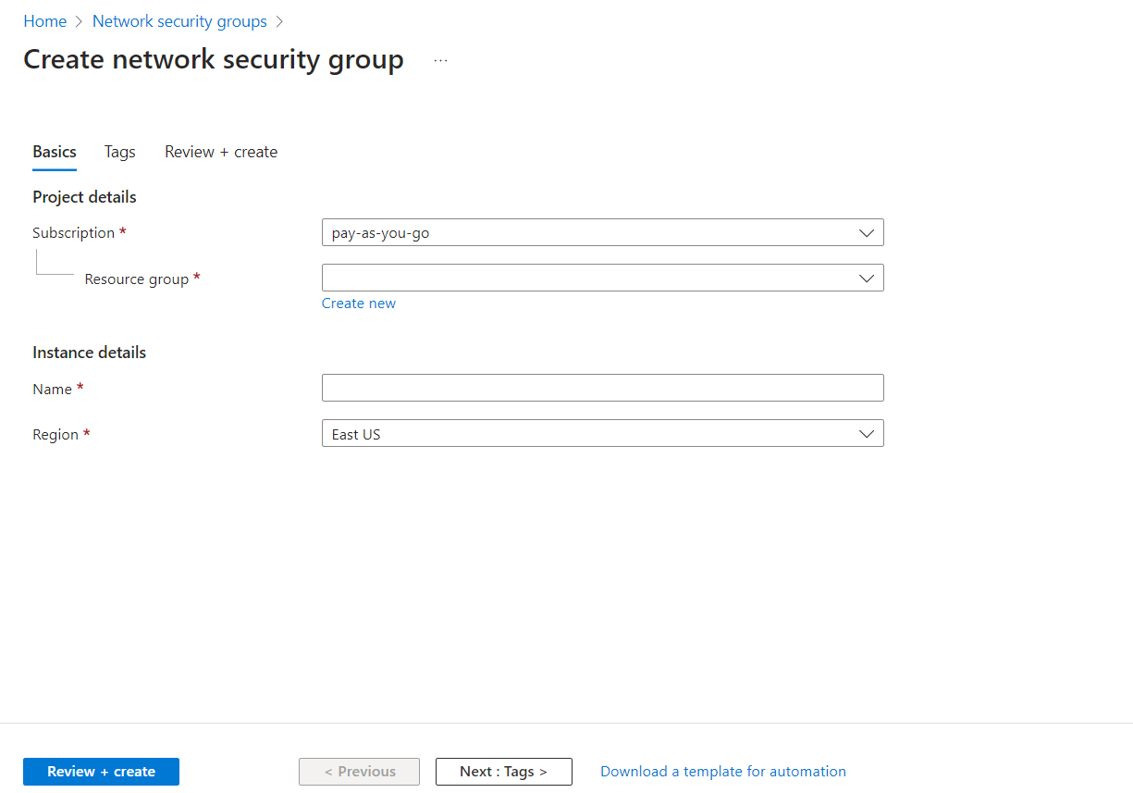

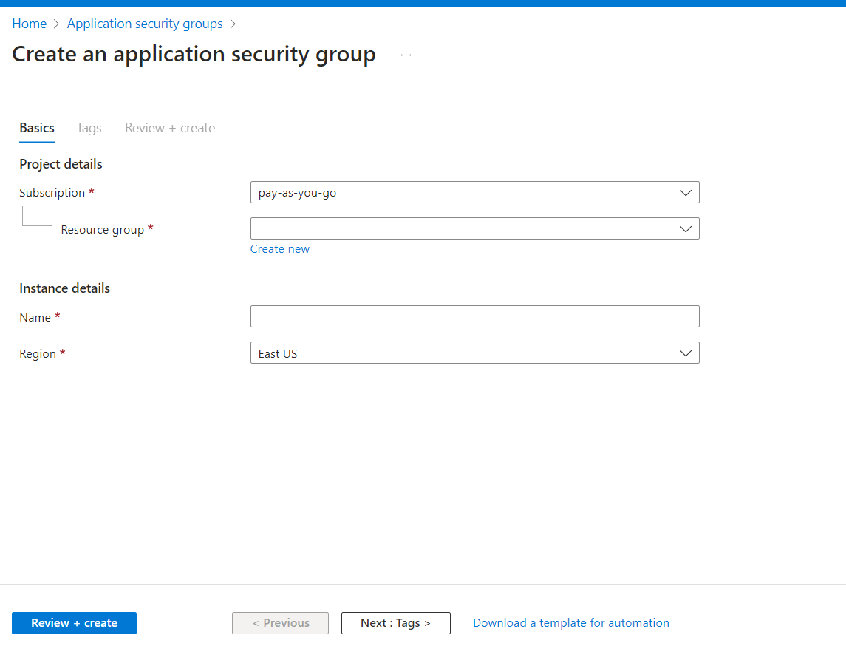

Application sg is one of the part of NSG

9. Did u wrk on a power shell with azure?

<https://learn.microsoft.com/en-us/powershell/azure/azureps-vm-tutorial?view=azps-11.1.0&tutorial-step=1>

<https://stackoverflow.com/questions/47023019/running-a-powershell-script-involving-azurerm-as-an-azure-webjob>